Introduction of Object Oriented Programming
• Read
• Courses
• Practice

As the name suggests, Object-Oriented Programming or OOPs refers to languages that use objects in programming. Object-oriented programming aims to implement real-world entities like inheritance, hiding, polymorphism, etc in programming. The main aim of OOP is to bind together the data and the functions that operate on them so that no other part of the code can access this data except that function.
OOPs Concepts:
- Class
- Objects
- Data Abstraction
- Encapsulation
- Inheritance
- Polymorphism
- Dynamic Binding
- Message Passing
1. Class:
A class is a user-defined data type. It consists of data members and member functions, which can be accessed and used by creating an instance of that class. It represents the set of properties or methods that are common to all objects of one type. A class is like a blueprint for an object.
For Example: Consider the Class of Cars. There may be many cars with different names and brands but all of them will share some common properties like all of them will have 4 wheels, Speed Limit, Mileage range, etc. So here, Car is the class, and wheels, speed limits, mileage are their properties.
2. Object:
It is a basic unit of Object-Oriented Programming and represents the real-life entities. An Object is an instance of a Class. When a class is defined, no memory is allocated but when it is instantiated (i.e. an object is created) memory is allocated. An object has an identity, state, and behavior. Each object contains data and code to manipulate the data. Objects can interact without having to know details of each other’s data or code, it is sufficient to know the type of message accepted and type of response returned by the objects.
For example “Dog” is a real-life Object, which has some characteristics like color, Breed, Bark, Sleep, and Eats.
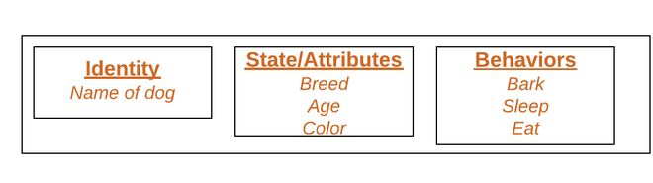
Object
3. Data Abstraction:
Data abstraction is one of the most essential and important features of object-oriented programming. Data abstraction refers to providing only essential information about the data to the outside world, hiding the background details or implementation. Consider a real-life example of a man driving a car. The man only knows that pressing the accelerators will increase the speed of the car or applying brakes will stop the car, but he does not know about how on pressing the accelerator the speed is increasing, he does not know about the inner mechanism of the car or the implementation of the accelerator, brakes, etc in the car. This is what abstraction is.
4. Encapsulation:
Encapsulation is defined as the wrapping up of data under a single unit. It is the mechanism that binds together code and the data it manipulates. In Encapsulation, the variables or data of a class are hidden from any other class and can be accessed only through any member function of their class in which they are declared. As in encapsulation, the data in a class is hidden from other classes, so it is also known as data-hiding.
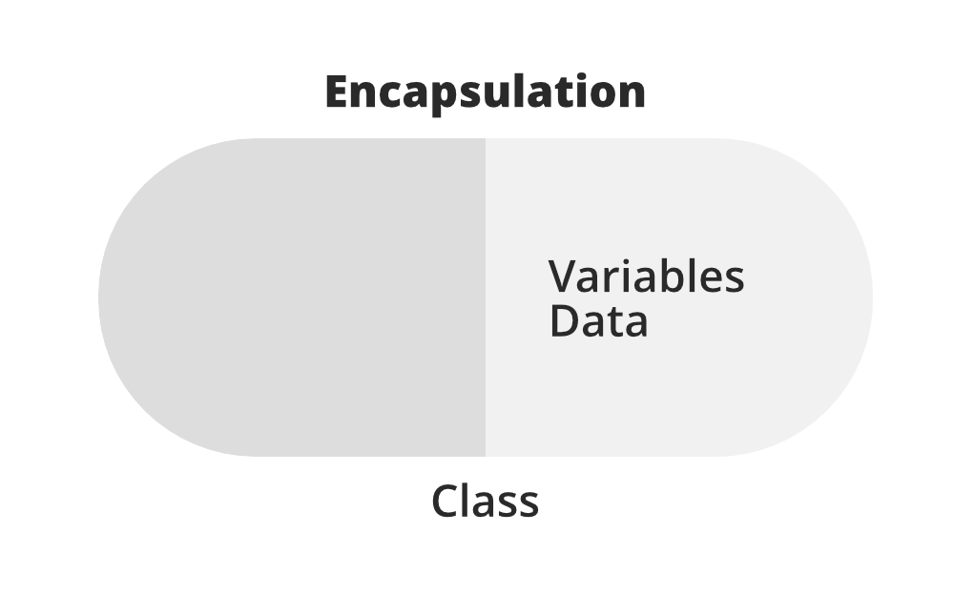
Consider a real-life example of encapsulation, in a company, there are different sections like the accounts section, finance section, sales section, etc. The finance section handles all the financial transactions and keeps records of all the data related to finance. Similarly, the sales section handles all the sales-related activities and keeps records of all the sales. Now there may arise a situation when for some reason an official from the finance section needs all the data about sales in a particular month. In this case, he is not allowed to directly access the data of the sales section. He will first have to contact some other officer in the sales section and then request him to give the particular data. This is what encapsulation is. Here the data of the sales section and the employees that can manipulate them are wrapped under a single name “sales section”.
5. Inheritance:
Inheritance is an important pillar of OOP(Object-Oriented Programming). The capability of a class to derive properties and characteristics from another class is called Inheritance. When we write a class, we inherit properties from other classes. So when we create a class, we do not need to write all the properties and functions again and again, as these can be inherited from another class that possesses it. Inheritance allows the user to reuse the code whenever possible and reduce its redundancy.
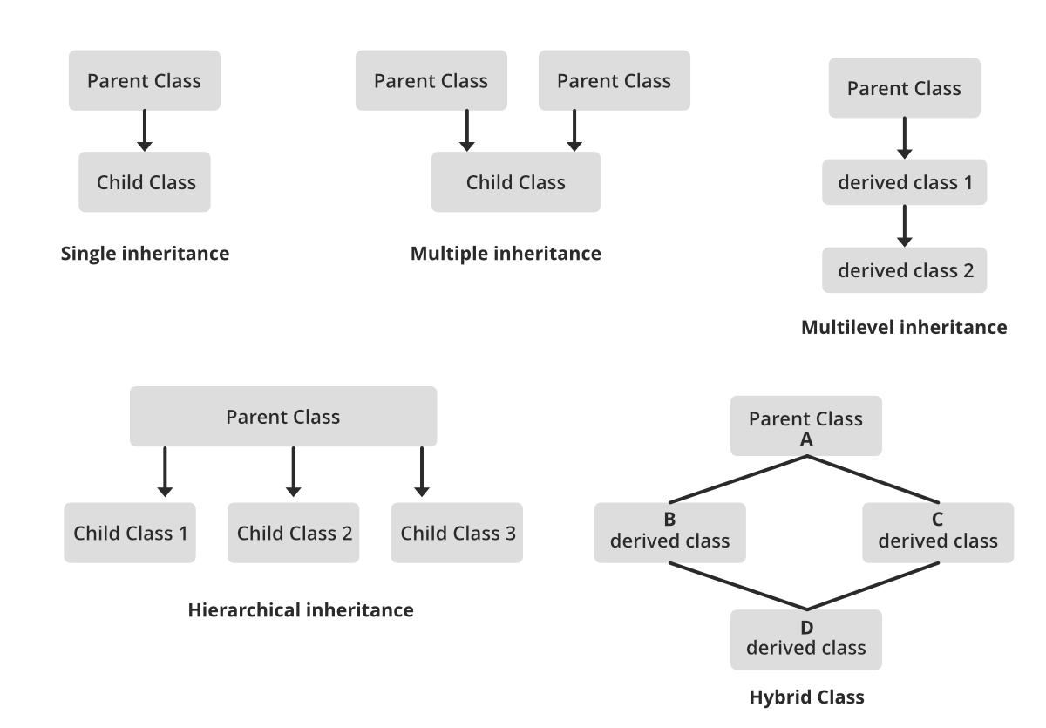
6. Polymorphism:
The word polymorphism means having many forms. In simple words, we can define polymorphism as the ability of a message to be displayed in more than one form. For example, A person at the same time can have different characteristics. Like a man at the same time is a father, a husband, an employee. So the same person posses different behavior in different situations. This is called polymorphism.
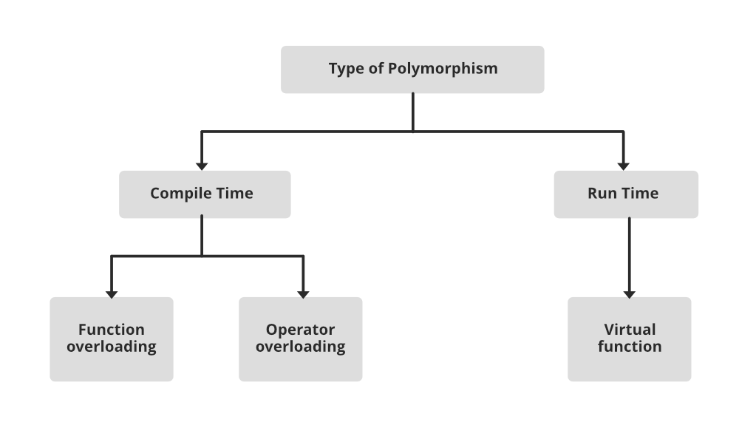
7. Dynamic Binding:
In dynamic binding, the code to be executed in response to the function call is decided at runtime. Dynamic binding means that the code associated with a given procedure call is not known until the time of the call at run time. Dynamic Method Binding One of the main advantages of inheritance is that some derived class D has all the members of its base class B. Once D is not hiding any of the public members of B, then an object of D can represent B in any context where a B could be used. This feature is known as subtype polymorphism.
8. Message Passing:
It is a form of communication used in object-oriented programming as well as parallel programming. Objects communicate with one another by sending and receiving information to each other. A message for an object is a request for execution of a procedure and therefore will invoke a function in the receiving object that generates the desired results. Message passing involves specifying the name of the object, the name of the function, and the information to be sent.
Why do we need object-oriented programming
- To make the development and maintenance of projects more effortless.
- To provide the feature of data hiding that is good for security concerns.
- We can solve real-world problems if we are using object-oriented programming.
- It ensures code reusability.
- It lets us write generic code: which will work with a range of data, so we don’t have to write basic stuff over and over again.

What is Object-Oriented Programming?
Object-oriented programming has a sweeping impact because it appeals at multiple levels and promises faster and cheaper development and maintenance. It follows a bottom-up approach to develop applications.
In this section, we will discuss in-depth what is object-oriented programming?

Object-Oriented Programming
The word object-oriented is the combination of two words i.e. object and oriented. The dictionary meaning of the object is an article or entity that exists in the real world. The meaning of oriented is interested in a particular kind of thing or entity. In layman's terms, it is a programming pattern that rounds around an object or entity are called object-oriented programming.
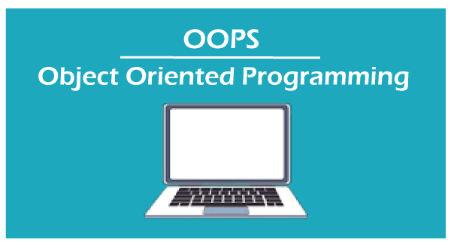
The technical definition of object-oriented programming is as follows:
The object-oriented programming is basically a computer programming design philosophy or methodology that organizes/ models software design around data, or objects rather than functions and logic.
An object is referred to as a data field that has unique attributes and behavior. Everything in OOP is grouped as self-sustainable objects.
It is the most popular programming model among developers. It is well suited for programs that are large, complex, and actively updated or maintained. It simplifies software development and maintenance by providing major concepts such as abstraction, inheritance, polymorphism, and encapsulation. These core concepts support OOP.
A real-world example of OOP is the automobile. It more completely illustrates the power of object-oriented design.

Points to Remember
- Everything is an object
- Developer manipulates objects that uses message passing.
- Every object is an instance of a class.
- The class contains the attribute and behavior associated with an object.

Pillars of OOPs
The major concepts that we have discussed above are known as pillars of OOPs. There are four pillars on which OOP rests.
- Abstraction
- Encapsulation
- Inheritance
- Polymorphism
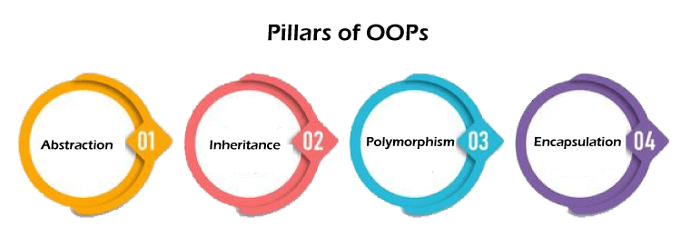
Let's discuss each in detail.

Abstraction
The concept allows us to hide the implementation from the user but shows only essential information to the user. Using the concept developer can easily make changes and added over time.
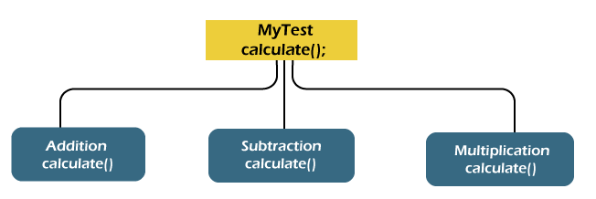
There are the following advantages of abstraction:
- It reduces complexity.
- It avoids delicacy.
- Eases the burden of maintenance
- Increase security and confidentially.

Encapsulation
Encapsulation is a mechanism that allows us to bind data and functions of a class into an entity. It protects data and functions from outside interference and misuse. Therefore, it also provides security. A class is the best example of encapsulation.
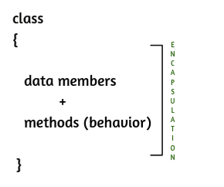

Inheritance
The concept allows us to inherit or acquire the properties of an existing class (parent class) into a newly created class (child class). It is known as inheritance. It provides code reusability.
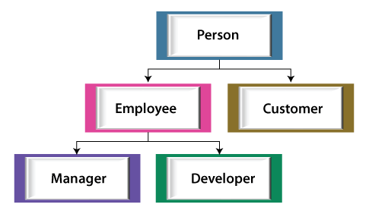

Polymorphism
The word polymorphism is derived from the two words i.e. ploy and morphs. Poly means many and morphs means forms. It allows us to create methods with the same name but different method signatures. It allows the developer to create clean, sensible, readable, and resilient code.
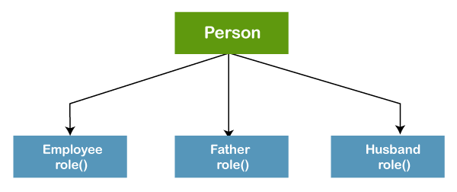
The above figure best describes the concepts of polymorphism. A person plays an employee role in the office, father and husband role in the home.

OOPs Concepts
The OOPs concepts include the following:
- Object
- Class
- Inheritance
- Polymorphism
- Abstraction
- Encapsulation
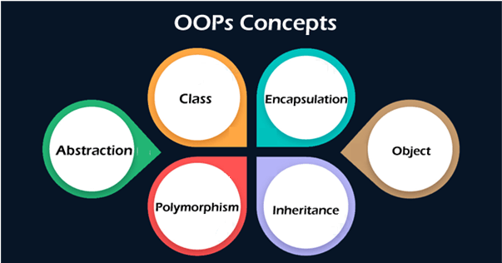

Object
An object is a real-world entity that has attributes, behavior, and properties. It is referred to as an instance of the class. It contains member functions, variables that we have defined in the class. It occupies space in the memory. Different objects have different states or attributes, and behaviors.

Class
A class is a blueprint or template of an object. It is a user-defined data type. Inside a class, we define variables, constants, member functions, and other functionality. it binds data and functions together in a single unit. It does not consume memory at run time. Note that classes are not considered as a data structure. It is a logical entity. It is the best example of data binding. Note that a class can exist without an object but vice-versa is not possible.
The following figure best illustrates the class and object in OOP.
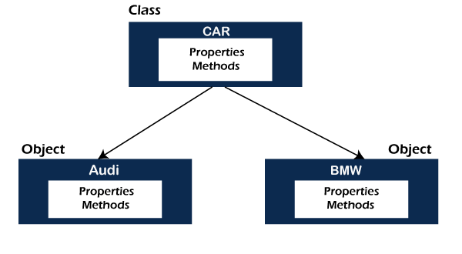
Apart from these core concepts, there are some other object-oriented concepts used in OOP.

Coupling
In programming, separation of concerns is known as coupling. It means that an object cannot directly change or modify the state or behavior of other objects. It defines how closely two objects are connected together. There are two types of coupling, loose coupling, and tight coupling.
Objects that are independent of one another and do not directly modify the state of other objects is called loosely coupled. Loose coupling makes the code more flexible, changeable, and easier to work with.
Objects that depend on other objects and can modify the states of other objects are called tightly coupled. It creates conditions where modifying the code of one object also requires changing the code of other objects. The reuse of code is difficult in tight coupling because we cannot separate the code.
Since using loose coupling is always a good habit.

Cohesion
In OOP, cohesion refers to the degree to which the elements inside a module belong together. It measures the strength of the relationship between the module and data. In short, cohesion represents the clarity of the responsibilities of a module. It is often contrasted with coupling.
It focuses on a how single module or class is intended. Higher the cohesiveness of the module or class, better is the object-oriented design.
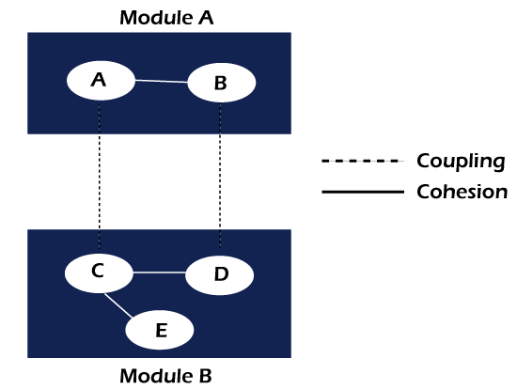
There are two types of cohesion, i.e. High and Low.
- High cohesion is associated with several required qualities of software including robustness, reliability, and understandability.
- Low cohesion is associated with unwanted qualities such as being difficult to maintain, test, reuse, or even understand.
High cohesion often associates with loose coupling and vice versa.

Composition
Composition is one of the vital concepts in OOP. It describes a class that references one or more objects of other classes in instance variables. It allows us to model a has-a association between objects. We can find such relationships in the real world. For example, a car has an engine. the following figure depicts the same
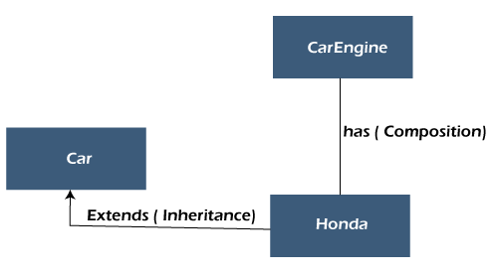
The main benefits of composition are:
- Reuse existing code
- Design clean APIs
- Change the implementation of a class used in a composition without adapting any external clients.

Association
The association defines the relationship between the objects. Note that an object can be associated with one or more than one object. The relationship can be unidirectional or bidirectional. There are the following types of association.
- One to One
- One to Many
- Many to One, and
- Many to Many

Aggregation
It is an advanced form of association in which each object has its own Lifecycle but there exists ownership as well. In other words, a relationship where a child can exist independently of the parent. It is also termed as has-a relationship in Java. Like, inheritance represents the is-a relationship. It is another way to reuse objects.

Why should we use OOP?
Object-oriented programming is an evolutionary development in software engineering. Using OOP in software development is a good habit because it accomplishes the three major software engineering goals, as we have shown in the following figure.
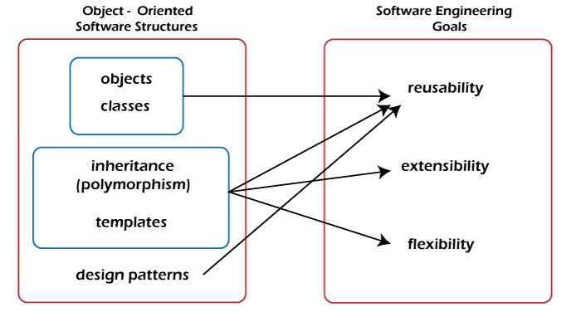

Where it is used?
OOP is often the best use when we are dealing with manufacturing and designing applications. It provides modularity in programming. It allows us to break down the software into chunks of small problems that we then can solve one object at a time.
It should be used where the reusability of code and maintenance is a major concern. Because it makes development easy and we can easily append code without affecting other code blocks. It should be used where complex programming is a challenge.

Benefits of OOP
- Modular, scalable, extensible, reusable, and maintainable.
- It models the complex problem in a simple structure.
- Object can be used across the program.
- Code can be reused.
- We can easily modify, append code without affecting the other code blocs.
- Provides security through encapsulation and data hiding features.
- Beneficial to collaborative development in which a large project is divided into groups.
- Debugging is easy.

Limitations of OOP
- Requires intensive testing processes.
- Solving problems takes more time as compared to Procedure Oriented Programming.
- The size of the programs created using this approach may become larger than the programs written using the procedure-oriented programming approach.
- Software developed using this approach requires a substantial amount of pre-work and planning.
- OOP code is difficult to understand if you do not have the corresponding class documentation.
- In certain scenarios, these programs can consume a large amount of memory.
- Not suitable for small problems.
- Takes more time to solve problems.

List of Object-Oriented Programming Languages
There are various object-oriented programming languages are present. But we have enlisted some popular and widely used OOP languages.
According to the TIOBE index, the top twenty OOP languages are Java, C++, C#, Python, R, PHP, Visual Basic.NET, JavaScript, Ruby, Perl, Object Pascal, Objective-C, Dart, Swift, Scala, Kotlin, Common Lisp, MATLAB, and Smalltalk.

Applications of OOPs
- Computer graphics applications
- Object-oriented database
- User-interface design such as windows
- Real-time systems
- Simulation and modeling
- Client-Server System
- Artificial Intelligence System
- CAD/CAM Software
- Office automation system

